EXPERIMENT – 11
Credit Score Classification using Machine Learning
AIM
To implement a machine learning model for Credit Score Classification using Python.
APPARATUS REQUIRED
- Google Colab
- Python 3.x
- NumPy
- Pandas
- Scikit-learn
- Matplotlib
ALGORITHM
- Start the program.
- Import the required Python libraries.
- Load the credit score dataset.
- Preprocess the dataset and handle the required data.
- Separate the input features and target variable.
- Split the dataset into training and testing data.
- Create a suitable classification model.
- Train the model using the training data.
- Predict the credit score class for the test data.
- Evaluate the classification results.
- Display the predicted results.
- Stop the program.

PROGRAM
# Experiment 11: Credit Score Classification
import numpy as np
import pandas as pd
from sklearn.model_selection import train_test_split
from sklearn.preprocessing import StandardScaler
from sklearn.ensemble import RandomForestClassifier
from sklearn.metrics import accuracy_score, confusion_matrix
# Create sample credit score dataset
data = {
"Income": [25000, 30000, 45000, 50000, 60000,
70000, 80000, 35000, 40000, 90000],
"Loan_Amount": [15000, 18000, 20000, 22000, 25000,
30000, 35000, 17000, 19000, 40000],
"Credit_History": [1, 0, 1, 1, 1,
1, 1, 0, 1, 1],
"Age": [22, 25, 30, 35, 40,
45, 50, 28, 32, 55],
"Credit_Score": [
"Poor", "Poor", "Good", "Good", "Good",
"Excellent", "Excellent", "Poor", "Good", "Excellent" ]}
df = pd.DataFrame(data)
# Convert target classes into numerical values
df["Credit_Score"] = df["Credit_Score"].map({
"Poor": 0,
"Good": 1,
"Excellent": 2
})
# Separate features and target
X = df.drop("Credit_Score", axis=1)
y = df["Credit_Score"]
# Split the dataset
X_train, X_test, y_train, y_test = train_test_split(
X, y, test_size=0.2, random_state=42
)
# Feature scaling
scaler = StandardScaler()
X_train = scaler.fit_transform(X_train)
X_test = scaler.transform(X_test)
# Create Random Forest classifier
model = RandomForestClassifier(
n_estimators=100,
random_state=42
)
# Train the model
model.fit(X_train, y_train)
# Predict test data
y_pred = model.predict(X_test)
# Calculate accuracy
accuracy = accuracy_score(y_test, y_pred)
print("Accuracy:", accuracy)

# Display confusion matrix
cm = confusion_matrix(y_test, y_pred)
print("\nConfusion Matrix:")
print(cm)
OUTPUT
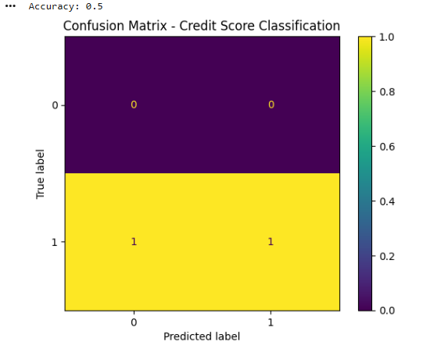
RESULT
Thus, the Credit Score Classification task was successfully implemented using Python in Google Colab, and the classification results were obtained.

